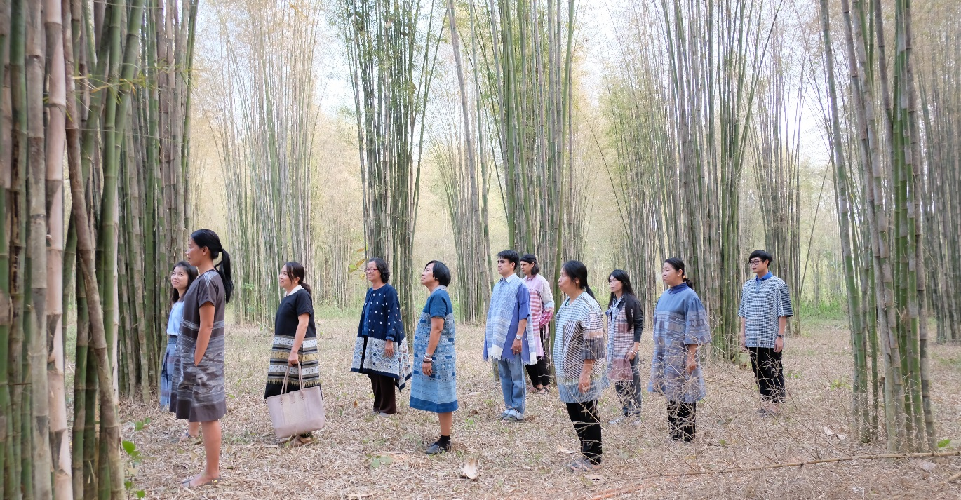
Crafting Futures at European Development Days, Brussels, 18-19 June 2019
European Development Days, Brussels, 18-19 June 2019
with Jirapat Changlek and Alisa Ruzavina
Brussels – Crafting Futures is a global programme run by British Council that strengthens the crafts sector around the globe for reduced social and economic inequalities. It is making a valuable contribution to ensuring that craft is appreciated more broadly: by uniting the old with the new, handmade with digital, rural with urban, cultural with economic - ensuring parity for all. It offers designers and artisans access to knowledge and expertise, new markets and new audiences. Crafting Futures is active in in East Asia, South Asia, Central Asia and the South Caucasus, the EU and the Americas. It has expanded to 30 countries and supported more than 50 projects since it started.
British Council will be hosting a Crafting Futures stand at the European Development Days where case studies from Malaysia, Mexico, Myanmar, Pakistan, Panama and Thailand will be highlighted. You will hear about how the programme brings people together to bridge social and economic divides directly from Jirapat Changlek, a Thai weaver from Nan Province, and Alisa Ruzavina, a young designer working in Guna Yala, the autonomous, indigenous areas of Panama. You will have the chance to engage with them in creative production through weaving workshops and try on authentic Thai clothes!

About Alisa Ruzavina and Jirapet Changlek
’The future of the Mola blouse is in the hands of the women of Guna Yala. With a little help from the Crafting Futures initiative, it continues to provide a canvas to tell their stories of independence as well as becoming a platform for environmental activism and economic empowerment.’ Alisa Ruzavina.
Alisa will be present at the stand throughout the EDDs together with Jirapat, an artisan from Thailand, hosting workshops on weaving and applique techniques, engage visitors and share with them how they have revitalised traditional cultural heritage, economically and socially empowered local women and tackled the challenges of climate change through sustainable and ethical production and consumption.

Find out more about Crafting Futures
- https://design.britishcouncil.org/projects/crafting-futures

Contact / Interviews
If you would like to feature Crafting Futures in an article or arrange an interview with one or more of our guests at the stand, and/or a member of the British Council team, please contact
Martina Tesseri
martina.tesseri@britishcouncil.be
+32 (0)2 554 04 64

Note to Editors:
About the British Council
The British Council is the UK’s international organisation for cultural relations and educational opportunities. We create friendly knowledge and understanding between the people of the UK and other countries. We do this by making a positive contribution to the UK and the countries we work with – changing lives by creating opportunities, building connections and engendering trust.
We work with over 100 countries across the world in the fields of arts and culture, English language, education and civil society. Each year we reach over 20 million people face-to-face and more than 500 million people online, via broadcasts and publications. Founded in 1934, we are a UK charity governed by Royal Charter and a UK public body.
About Crafting Futures
Crafting Futures is active in 30 countries all over the world, and is part of British Council’s creative response to the SDGs. Our projects actively engage with and amplify the voices of women artisans and rural communities, by providing education, new networks, markets and opportunities for shared learning between the UK and other countries around the globe.
For more information, please visit: www.britishcouncil.org. You can also keep in touch with the British Council through http://twitter.com/britishcouncil and http://blog.britishcouncil.org/.

