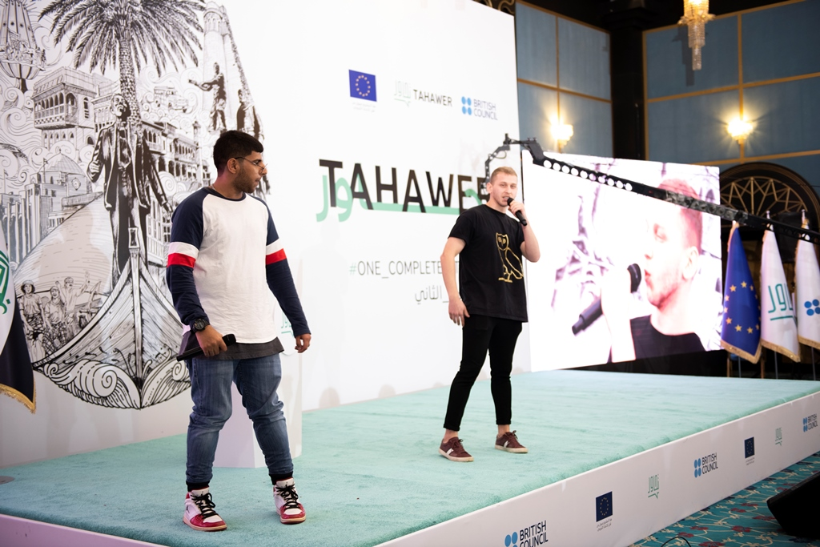

**Breaking the cycle of inequality in the MENA through cultural approaches**

**European Development Days, Brussels, 18-19 June 2019**

*with Amina El Abed, Sakar Al Zakariya, Rahaf Alsharif, Genesis and Maamar*

**Brussels** – On 18-19 June 2019, the British Council, the United Kingdom's international organisation for cultural relations and educational opportunities, will host a project lab at the European Development Days in Brussels.

**Culture and Communication enable individuals and groups to construct personal and cultural identities**, provide them with a platform for a more diverse range of voices to be heard, build capability of people with influence and marginalized groups to work together to solve problems; and, in doing so, build resilience and **provide an alternative to divisive narratives that exploit inequalities**. Unaddressed inequalities are grist to the mill of divisive narratives – and are often exploited to fuel violence. Through its work in **Iraq**, **Lebanon** and **Syria**, the British Council is leading development projects that aim to enable these platforms to emerge and thrive and facilitate opportunities for people with influence and marginalised groups to work together to solve problems.

The session will explore the **potential of culture and communications** as an approach in development programming, drawing on insights into what has worked, and the lessons learned from three British Council projects. It will draw on their experiences and on evidence generated by programmes in Iraq, Lebanon and Syria, to debate the power of cultural communications and relations and consider the implications for the sector. The speakers, who are contributing to these programmes, will share examples from their own experience of ways in which young women and men use culture and communication to participate in and lead development and peace processes. Their stories will highlight a range of ways in which the theory is being put into practice. The discussion will also draw on data and research generated by the programmes.

**Find out more about the projects**

* **Aswat Faeela**: <http://aswatfaeela.org/>
* **Tahawer**: <https://www.facebook.com/Tahawer-Programme-1665468653559592/>
* **Strengthening Resilience**: <https://www.britishcouncil.org/partner/international-development/news-and-events/march-2018/Strengthening-Resilience-in-MENA>

**Contact / Interviews**

If you would like to feature one or more of the programmes presented in an article or arrange an interview with one or more of our guests, and/or a member of the British Council team, please contact:

Martina Tesseri

[martina.tesseri@britishcouncil.be](mailto:martina.tesseri@britishcouncil.be)

+32 (0)2 554 04 64

**Note to Editors:**

**About the British Council**

The British Council is the UK’s international organisation for cultural relations and educational opportunities. We create friendly knowledge and understanding between the people of the UK and other countries. We do this by making a positive contribution to the UK and the countries we work with – changing lives by creating opportunities, building connections and engendering trust.

We work with over 100 countries across the world in the fields of arts and culture, English language, education and civil society. Each year we reach over 20 million people face-to-face and more than 500 million people online, via broadcasts and publications. Founded in 1934, we are a UK charity governed by Royal Charter and a UK public body.

For more information, please visit: [www.britishcouncil.org](http://www.britishcouncil.org). You can also keep in touch with the British Council through <http://twitter.com/britishcouncil> and <http://blog.britishcouncil.org/>.